Chapter 5

Establishing the business requirements

ارزیابی نیاز های تجاری

مقدمه

This chapter describes the vision and scope document, a deliverable that contains the project’s business requirements. Figure 5-3 later in this chapter suggests a template for the vision and scope document. But before we get to the template, let’s see just what we mean by “business requirements

این بخش چشم انداز و محدود سند که قابل ارائه است که شامل نیازمندی های تجاری پروژه است .

شکل زیر یک تمپلیت پیشنهادی برای محدوده و چشم انداز اسناد ارائه می دهد . اما قبل از آن باید تعریف از نیاز مندی های تجاری داشته باشیم .

تعریف نیاز مندی ها تجاری

Defining business requirements

“Business requirements” refers to a set of information that, in the aggregate, describes a need that leads to one or more projects to deliver a solution and the desired ultimate business outcomes. Business opportunities, business objectives, success metrics, and a vision statement make up the business requirements.

"نیازمندی های تجاری " اشاره میکند به مجموعه ای از اطلاعات که ، در مجموع ، نیازی را توصیف میکند که منجر به ایجاد یک یا چند پروژه برای ارائه راه حل و نتایج مطلوب تجاری میشود .

فرصت های تجاری ، اهداف تجاری ، معیار های موفقیت و یک بیانیه چشم انداز چیزهایی هستند که نیازمندی های تجاری را تشکیل میدهند .

Business requirements issues must be resolved before the functional and nonfunctional requirements can be fully specified. A statement of the project’s scope and limitations helps greatly with discussions of proposed features and target releases. The business requirements provide a reference for making decisions about proposed requirement changes and enhancements. We recommend displaying the business objectives, vision, and scope highlights in every requirements elicitation session so the team can quickly judge whether a proposed requirement is in or out of scope.

مسائل مربوط به نیازمندی های تجاری باید قبل از مشخص شدن کامل الزامات عملکردی و غیر عملکردی حل شوند . بیانی از محدوده و محدودیت های پروژه به بحث درمورد ویژگی های پیشنهادی و نسخه هدف کمک بسیاری میکند . ما توصیه میکنیم اهداف تجاری ، بیانیه و نقاط برجسته محدوده در هر جلسه استخراج نمایش داده تا تیم بتواند قضاوت کند که یک نیاز پیشنهادی خارج از محدوده است یا داخل آن .

Identifying desired business benefits

شناسایی مزایای کسب و کار مورد نظر

The business requirements set the context for, and enable the measurement of, the benefits the business hopes to achieve from undertaking a project. Organizations should not initiate any project without a clear understanding of the value it will add to the business. Set measurable targets with business objectives, and then define success metrics that allow you to measure whether you are on track to meet those objectives.

مجموعه نیازمندی های تجاری زمینه را برای اندازه گیری مزایایی که کسب و کار امیداوار است از انجام یک پروژه بدست بیاورد را ، تنظیم می کند . سازمان ها هیچ پروژه ای را بدون یک درک روشن از ارزش آنچه که به کسب و کار مورد نظر افزوده خواهد شد ، نباید شروع کنند . اهداف قابل اندازه گیری را با اهداف تجاری تعیین کیند و سپس معیار های موفقیت را تعریف کنید که به شما اجازه میدهند که اندازه گیری کنید آیا در مسیر رسیدن به اهداف هستیید یا خیر .

Business requirements might come from funding sponsors, corporate executives, marketing managers, or product visionaries. However, it can be challenging to identify and communicate the business benefits

نیازمندی های تجاری ممکن از طرف حامیان مالی ، مدیران شرکت ، مدیران مالی مشخص شده باشد . با این حال شناسایی و ارتباط با مزایای کسب و کار ممکن است چالش برانگیز باشد .

The business benefit has to represent a true value for the project’s sponsors and to the product’s customers. For example, simply merging two systems into one is not a reasonable business objective

Product vision and project scope

چشم انداز محصول و محدوده پرژه

Two core elements of the business requirements are the vision and the scope. The product vision succinctly describes the ultimate product that will achieve the business objectives. This product could serve as the complete solution for the business requirements or as just a portion of the solution. The vision describes what the product is about and what it ultimately could become. It provides the context for making decisions throughout the product’s life, and it aligns all stakeholders in a common direction. The project scope identifies what portion of the ultimate product vision the current project or development iteration will address. The statement of scope draws the boundary between what’s in and what’s out for this project.

دو هسته اصلی نیازمندی های تجاری چشم انداز و محدوده هستند . چشم انداز محصول به طور خلاصه محصول نهایی را توصیف می کند که به اهداف تجاری دست می یابد. این محصول می تواند به عنوان راه حل کامل برای نیازهای تجاری یا فقط به عنوان بخشی از راه حل باشد.چشم انداز توصیف میکند که محصول در مورد چه چیز است و درنهایت چه خواهد شد . این زمینه را برای تصمیم گیری در طول عمر محصول فراهم می کند و همه سهامداران را در یک جهت مشترک قرار می دهد. محدوده پروژه مشخص می کند که پروژه فعلی یا تکرار توسعه به چه بخشی از چشم انداز محصول نهایی می پردازد. بیانیه دامنه مرزی بین آنچه در این پروژه وجود دارد و آنچه خارج است ترسیم می کند.

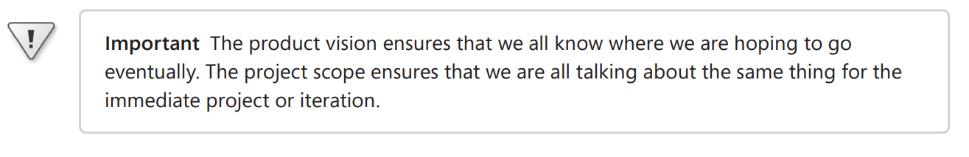

**مهم : چشم انداز محصول تضمین می کند که همه ما می دانیم که امیدواریم در نهایت به کجا برویم. محدوده پروژه تضمین می کند که همه ما در مورد یک پروژه یا تکرار فوری صحبت می کنیم.**

The vision applies to the product as a whole. The vision should change relatively slowly as a product’s strategic positioning or a company’s business objectives evolve over time. The scope pertains to a specific project or iteration that will implement the next increment of the product’s functionality, as shown in Figure 5-1. Scope is more dynamic than vision because the stakeholders adjust the contents of each release within its schedule, budget, resource, and quality constraints. Scope for the current release should be clear, but the scope of future releases will be fuzzier the farther out you look. The team’s goal is to manage the scope of a specific development or enhancement project as a defined subset of the strategic vision for the product.

چشم انداز در کل محصول ارائه میشود . با تغییر موقعیت استراتژیک محصول یا اهداف تجاری یک شرکت در طول زمان، چشم انداز باید نسبتاً آهسته تغییر کند. دامنه مربوط به یک پروژه یا تکرار خاص است که افزایش بعدی عملکرد محصول را اجرا می کند، همانطور که در شکل 5-1 نشان داده شده است. دامنه پویاتر از چشم انداز است زیرا ذینفعان محتویات هر نسخه را در چارچوب برنامه، بودجه، منابع و محدودیت های کیفیت تنظیم می کنند. . محدوده انتشار فعلی باید روشن باشد، اما دامنه انتشارات آینده هر چه دورتر نگاه کنید مبهم‌تر خواهد شد. هدف تیم مدیریت محدوده یک پروژه توسعه یا ارتقای خاص به عنوان زیرمجموعه تعریف شده از چشم انداز استراتژیک برای محصول است.

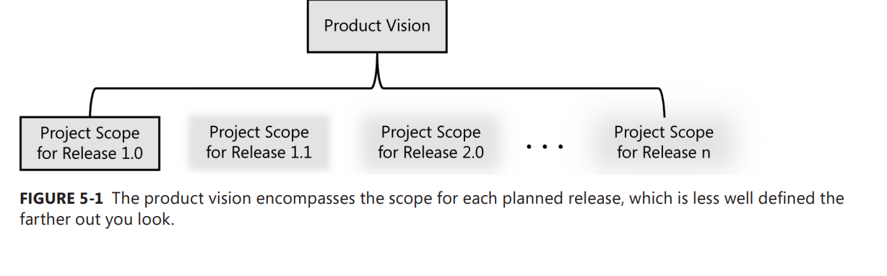

Conflicting business requirements

الزامات تجاری متناقض

Business requirements collected from multiple sources might conflict. Consider a kiosk that will be used by a retail store’s customers. Figure 5-2 shows the likely business interests of the kiosk developer, retailer, and customer as we envision how each of these stakeholders hopes the kiosk will provide an advantage over their current way of doing business

نیازمندیهای تجاری از چندین منبع که ممکن است با هم تناقص داشته باشند جمع آوری شوند . یک دکه را که قرار است توسط مشتریان یک خورده فروشی استفاده شود را در نظر بگیرید . . شکل 5-2 منافع تجاری احتمالی سازنده، خرده‌فروش و مشتری کیوسک را نشان می‌دهد، همانطور که ما تصور می‌کنیم که چگونه هر یک از این ذینفعان امیدوارند که کیوسک مزیتی نسبت به روش فعلی آنها برای انجام کسب‌وکار فراهم کند.

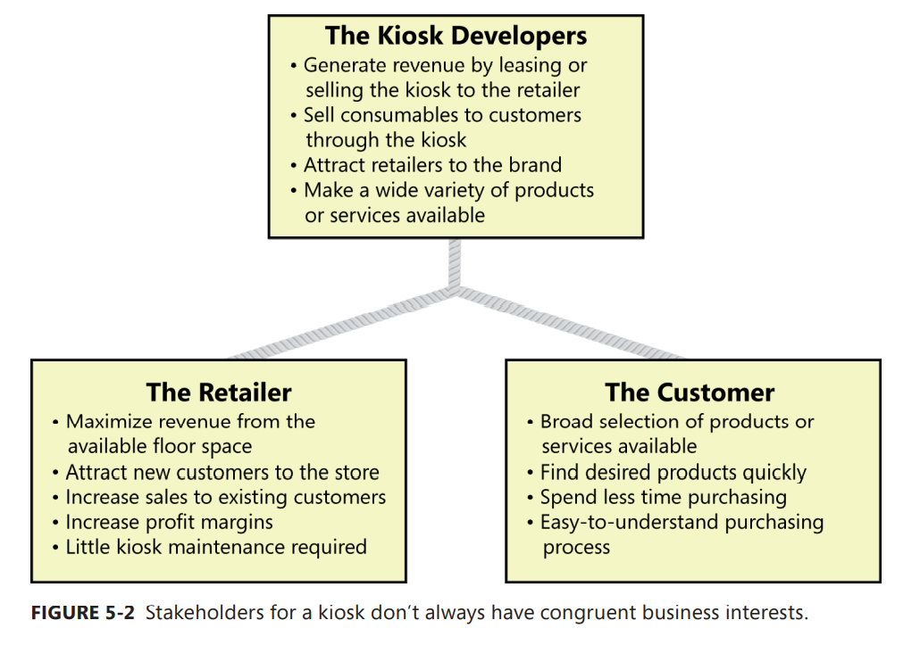

Vision and scope document

اسناد محدوده و چشم انداز

The vision and scope document collects the business requirements into a single deliverable that sets the stage for the subsequent development work. Some organizations create a project charter (Wiegers 2007) or a business case document that serves a similar purpose. Organizations that build commercial software often create a market (or marketing) requirements document (MRD). An MRD might go into more detail about the target market segments and the issues that pertain to commercial success.

سند چشم انداز و محدوده تمام نیازمندی های تجاری را تحت یک مجموعه قابل ارائه جمع آوری میکند و زمینه را برای ارائه های بعدی آماده میکند . بعضی سازمان ها یک سند منشور پروژه یا یک سند مورد تجاری که یک هدف یکسان را تامین میکنند پدید می آورند . سازمان هایی که نرم افزار های تجاری را می سازند اغلب یک سند نیازمندی های بازاریابی را به وجود می آورند . یک سند نیازمندی های بازاریابی ممکن است که به جزئیات بیشتری در مورد بخش های بازار هدف و ماسائل مربوط به موفقیت تجاری بپردازد .

The owner of the vision and scope document is the project’s executive sponsor, funding authority, or someone in a similar role. A business analyst can work with this individual to articulate the business requirements and write the vision and scope document. Input to the business requirements should come from people who have a clear sense of why they are undertaking the project. These individuals might include the customer or development organization’s senior management, a product visionary, a product manager, a subject matter expert, or members of the marketing department.

مالک سند چشم انداز و محدوده اسپانسرمالی پروژه ،مرجع تامین مالی و یا شخصی شبیه این نقش را دارد . یک تحلیلگر تجاری میتواند با این شخص کارکند تا الزامات کسب و کار را بیان کند و سند چشم انداز و محدوده را بنویسد . ورودی نیازمندی های کسب و کار باید از سوی افرادی باشد که درک روشن از چرایی اجرای پروژه دارند . این افراد ممکن شامل مشتری یا مدیریت ارشد شرکت توسعه دهند ، مشاهده کننده محصول ، مدیریت محصول ،متخصص موضوع، یا اعضاء واحد بازاریابی میشود .

Figure 5-3 suggests a template for a vision and scope document; the sections that follow describe each of the template headings in more detail. As with any template, adapt this to meet the specific needs of your own projects. If you already have recorded some of this information elsewhere, do not duplicate it in the vision and scope document. Some elements of the vision and scope document might be reusable from project to project, such as business objectives, business risks, and stakeholder profiles. Appendix C includes an example vision and scope document written according to this template.

شکل 5-3یک قالب برای سند چشم انداز و محدوده پیشنهاد میدهد ؛ ; بخش‌هایی که در ادامه می‌آیند، هر یک از سرفصل‌های قالب را با جزئیات بیشتری توضیح می‌دهند. مانند هر قالب دیگری، این را با نیازهای خاص پروژه های خود تطبیق دهید. اگر قبلاً برخی از این اطلاعات را در جای دیگری ثبت کرده اید، آن را در سند چشم انداز و محدوده کپی نکنید. برخی از عناصر سند چشم انداز و محدوده ممکن است از پروژه ای به پروژه دیگر قابل استفاده مجدد باشند، مانند اهداف تجاری، ریسک های تجاری، و مشخصات ذینفعان. پیوست C شامل یک نمونه سند چشم انداز و محدوده است که مطابق این الگو نوشته شده است.

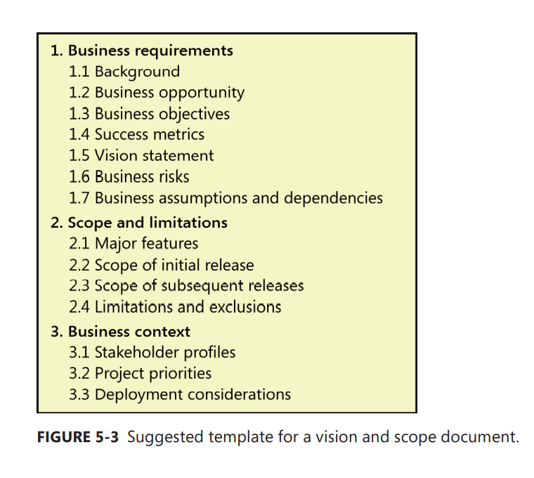

The vision and scope document only defines the scope at a high level; the scope details are represented by each release baseline that the team defines. Major new projects should have both a complete vision and scope document and an SRS. (See Chapter 10, “Documenting the requirements,” for an SRS template.) Each iteration, release, or enhancement project for an evolving product can include its own scope statement in that project’s requirements documentation, rather than creating a separate vision and scope document.

1. Business requirements

1- نیازمندی های تجاری

Projects are launched in the belief that creating or changing a product will provide worthwhile benefits for someone and a suitable return on investment. The business requirements describe the primary benefits that the new system will provide to its sponsors, buyers, and users. . Business requirements directly influence which user requirements to implement and in what sequence

پروژه ها با این باور راه اندازی میشوند که ایجاد یا تغییر یک محصول ممکن است مزایای ارزشمندی را برای کسی فراهم آورد و بازده سرمایه گذاری مناسبی را به همراه خواهد داشت . نیازمندی های تجاری مزایای اولیه که در سیستم جدید برای اسپانسر ها ، خریدارها و کاربران تامین خواهد شد را توصیف میکند . نیازمندی های تجاری به طور مستقیم تاثیر بر نیازمندی های کاربر برای پیاده سازی و ترتیب آن تاثیر میگذارد .

* 1. Background

1-1 پشت صحنه

* 1. Summarize the rationale and context for the new product or for changes to be made to an existing one. Describe the history or situation that led to the decision to build this product.

1.2 Business opportunity

For a corporate information system, describe the business problem that is being solved or the process being improved, as well as the environment in which the system will be used. For a commercial product, describe the business opportunity that exists and the market in which the product will be competing. This section could include a comparative evaluation of existing products, indicating why the proposed product is attractive and the advantages it provides. Describe the problems that cannot currently be solved without the envisioned solution. Show how it aligns with market trends, technology evolution, or corporate strategic directions. List any other technologies, processes, or resources required to provide a complete customer solution. Describe the needs of typical customers or of the target market. Present customer problems that the new product will address. Provide examples of how customers would use the product. Define any known critical interface or quality requirements, but omit design or implementation specifics.

1-3 اهداف تجاری

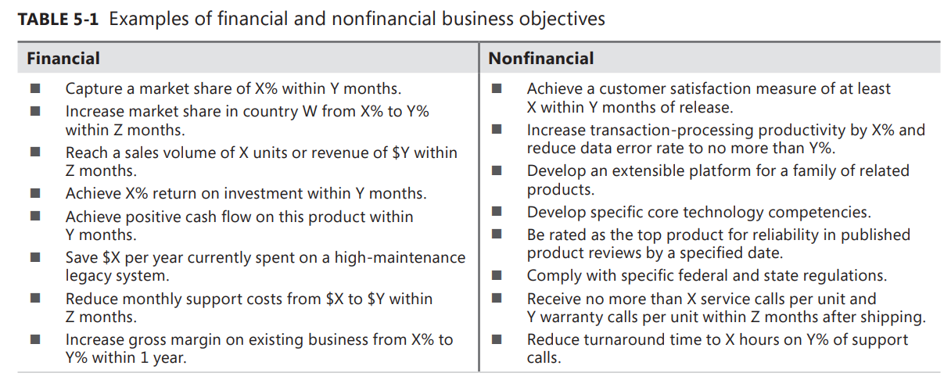

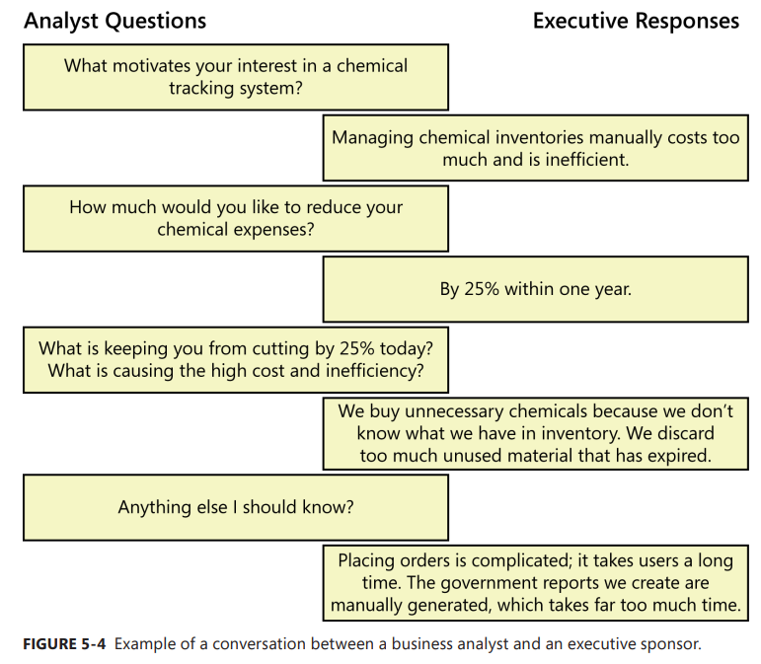

1-4 معیار های موفقیت

Specify the indicators that stakeholders will use to define and measure success on this project (Wiegerts 2007). Identify the factors that have the greatest impact on achieving that success, including factors both within and outside the organization’s control. Business objectives sometimes cannot be measured until well after a project is complete. In other cases, achieving the business objectives might be dependent on projects beyond your current one. However, it’s still important to evaluate the success of an individual project. Success metrics indicate whether a project is on track to meet its business objectives. The metrics can be tracked during testing or shortly after product release. For the Chemical Tracking System, one success metric might be the same as Business Objective 3 in Figure 5-5 to “Reduce time spent ordering chemicals to 10 minutes on 80 percent of orders,” because you can measure the average order time during testing or soon after release. Another success metric might relate to Business Objective 2 with a timeline that can be measured much earlier than a year after release, such as “Track 60 percent of commercial chemical containers and 50 percent of proprietary chemicals within 4 weeks

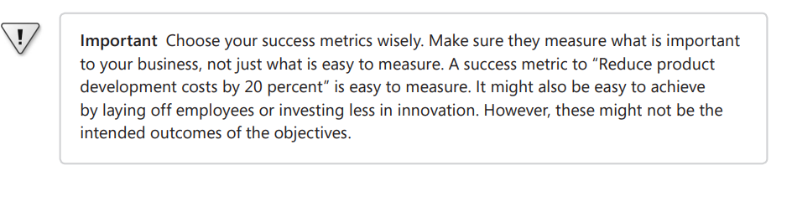

1-5 بیانیه چشم انداز

Write a concise vision statement that summarizes the long-term purpose and intent of the product. The vision statement should reflect a balanced view that will satisfy the expectations of diverse stakeholders. It can be somewhat idealistic but should be grounded in the realities of existing or anticipated markets, enterprise architectures, corporate strategic directions, and resource limitations. The following keyword template works well for crafting a product vision statement (Moore 2002):

■ For [target customer]

■ Who [statement of the need or opportunity]

■ The [product name]

■ Is [product category]

■ That [major capabilities, key beneft, compelling reason to buy or use]

■ Unlike [primary competitive alternative, current system, current business process]

■ Our product [statement of primary differentiation and advantages of new product]

Here’s a sample vision statement for the Chemical Tracking System, with the keywords in boldface: For scientists who need to request containers of chemicals, the Chemical Tracking System is an information system that will provide a single point of access to the chemical stockroom and to vendors. The system will store the location of every chemical container within the company, the quantity of material remaining in it, and the complete history of each container’s locations and usage. This system will save the company 25 percent on chemical costs in the frst year of use by allowing the company to fully exploit chemicals that are already available within the company, dispose of fewer partially used or expired containers, and use a standard chemical purchasing process. Unlike the current manual ordering processes, our product will generate all reports required to comply with federal and state government regulations that require the reporting of chemical usage, storage, and disposal

1-6 ریسک های تجاری

Summarize the major business risks associated with developing—or not developing—this product. Risk categories include marketplace competition, timing issues, user acceptance, implementation issues, and possible negative impacts on the business. Business risks are not the same as project risks, which often include resource availability concerns and technology factors. Estimate the potential loss from each risk, the likelihood of it occurring, and any potential mitigation actions. See Chapter 32, “Software requirements and risk management,” for more about this topic

1-7 فرضیات و وابتسگی های تجاری

An assumption is a statement that is believed to be true in the absence of proof or defnitive knowledge. Business assumptions are specifcally related to the business requirements. Incorrect assumptions can potentially keep you from meeting your business objectives. For example, an executive sponsor might set a business objective that a new website will increase revenue by $100,000 per month. To establish this revenue target, the sponsor made some assumptions, perhaps that the new site will attract 200 additional unique visitors per day and that each visitor will spend an average of $17. If the new site does not attract enough visitors with a high enough average sale per visitor, the project might not achieve its business objective. If you learn that certain assumptions are wrong, you might have to change scope, adjust the schedule, or launch other projects to achieve the objectives. Record any assumptions that the stakeholders made when conceiving the project and writing their vision and scope document. Often, one party’s assumptions are not shared by others. If you write them down and review them, you can avoid possible confusion and aggravation in the future. Record any major dependencies the project has on external factors. Examples are pending industry standards or government regulations, deliverables from other projects, third-party suppliers, or development partners. Some business assumptions and dependencies might turn into risks that the project manager must monitor regularly. Broken dependencies are a common source of project delays. Note the impact of an assumption not being true, or the impact of a broken dependency, to help stakeholders understand why it is critical.

2- دامنه و محدودیت ها

2-1 ویژگی های حداکثری

List the product’s major features or user capabilities, emphasizing those that distinguish it from previous or competing products. Think about how users will use the features, to ensure that the list is complete and that it does not include unnecessary features that sound interesting but don’t provide customer value. Give each feature a unique and persistent label to permit tracing it to other system elements. You might include a feature tree diagram, as described later in this chapter

2-2-محدوده نسخه اولیه

Summarize the capabilities that are planned for inclusion in the initial product release. Scope is often defned in terms of features, but you can also defne scope in terms of user stories, use cases, use case fows, or external events. Also describe the quality characteristics that will let the product provide the intended benefts to its various user classes. To focus the development effort and maintain a reasonable project schedule, avoid the temptation to include every feature that any potential customer might eventually want in release 1.0. Bloatware and slipped schedules are common outcomes of such insidious scope stuffng. Focus on those features that will provide the most value, at the most acceptable cost, to the broadest community, in the earliest time frame.

2-3 محدوده انتشارات بعدی

If you envision a staged evolution of the product, or if you are following an iterative or incremental life cycle, build a release roadmap that indicates which functionality chunks will be deferred and the desired timing of later releases. Subsequent releases let you implement additional use cases and features, as well as enriching the capabilities of the initial ones. The farther out you look, the fuzzier these future scope statements will be and the more they will change over time. Expect to shift functionality from one planned release to another and to add unanticipated capabilities. Short release cycles provide frequent opportunities for learning based on customer feedback.

2-4 محدودیت و محرومیت

List any product capabilities or characteristics that a stakeholder might expect but that are not planned for inclusion in the product or in a specifc release. List items that were cut from scope, so the scope decision is not forgotten. Maybe a user requested that she be able to access the system from her phone while away from her desk, but this was deemed to be out of scope. State that explicitly in this section: “The new system will not provide mobile platform support.

3- زمینه های تجاری

This section presents profles of major stakeholder categories, management’s priorities for the project, and a summary of some factors to consider when planning deployment of the solution

3-1 مشخصات ذینفعان

Stakeholders are the people, groups, or organizations that are actively involved in a project, are affected by its outcome, or are able to infuence its outcome (Smith 2000; IIBA 2009; PMI 2013). The stakeholder profles describe different categories of customers and other key stakeholders for the project. You needn’t describe every stakeholder group, such as legal staff who must check for compliance with pertinent laws on a website development project. Focus on different types of customers, target market segments, and the various user classes within those segments. Each stakeholder profle should include the following information:

■ The major value or benefit that the stakeholder will receive from the product. Stakeholder

value could be defend in terms of:

• Improved productivity.

CHAPTER 5 Establishing the business requirements 91

• Reduced rework and waste.

• Cost savings.

• Streamlined business processes.

• Automation of previously manual tasks.

• Ability to perform entirely new tasks.

• Compliance with pertinent standards or regulations.

• Improved usability compared to current products.

■ Their likely attitudes toward the product.

■ Major features and characteristics of interest.

■ Any known constraints that must be accommodated.

3-2 اولیت های پروژه

To enable effective decision making, the stakeholders must agree on the project’s priorities. One way to approach this is to consider the fve dimensions of features, quality, schedule, cost, and staff (Wiegers 1996). Each dimension fts in one of the following three categories on any given project:

■ Constraint A limiting factor within which the project manager must operate

■ Driver A signifcant success objective with limited fexibility for adjustment

■ Degree of freedom A factor that the project manager has some latitude to adjust and

balance against the other dimensions

The project manager’s challenge is to adjust the degrees of freedom to achieve the project’s success drivers within the limits imposed by the constraints. Suppose marketing suddenly demands that you release the product one month earlier than scheduled. How do you respond? Do you:

■ Defer certain requirements to a later release?

■ Shorten the planned system test cycle?

■ Demand overtime from your staff or hire contractors to accelerate development?

■ Shift resources from other projects to help out?

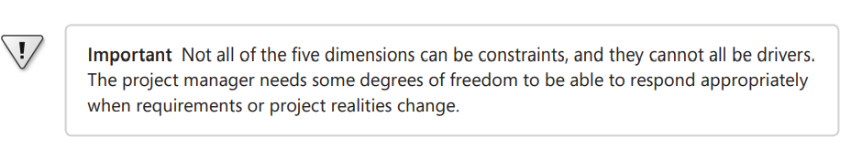

3-3 ملاحظات استقرار

Summarize the information and activities that are needed to ensure an effective deployment of the solution into its operating environment. Describe the access that users will require to use the system, such as whether the users are distributed over multiple time zones or located close to each other. State when the users in various locations need to access the system. If infrastructure changes are needed to support the software’s need for capacity, network access, data storage, or data migration, describe those changes. Record any information that will be needed by people who will be preparing training or modifying business processes in conjunction with deployment of the new solution

تکنیک های نمایش محدوده

The models described in this section can be used to represent project scope in various ways. You don’t need to create all of these models; consider which ones provide the most useful insight for each project. The models can be included in the vision and scope document or stored elsewhere and referenced as needed. The purpose of tools such as the context diagram, ecosystem map, feature tree, and event list is to foster clear and accurate communication among the project stakeholders. That clarity is more important than dogmatically adhering to the rules for a “correct” diagram. We strongly recommend, though, that you adopt the notations illustrated in the following examples as standards for drawing the diagrams. For example, in a context diagram, suppose you were to use a triangle to represent the system instead of a circle, and ovals rather than rectangles for external entities. Your colleagues would have diffculty reading a diagram that follows your personal preferences rather than a team standard. Context diagrams, ecosystem maps, feature trees, and event lists are the most common ways to represent scope visually. However, other techniques are also used. Identifying affected business processes also can help defne the scope boundary. Use case diagrams can depict the scope boundary between use cases and actors (see Chapter 8, “Understanding user requirements”).

نمودار زمینه

The scope description establishes the boundary and connections between the system you’re developing and everything else in the universe. The context diagram visually illustrates this boundary. It identifes external entities (also called terminators) outside the system that interface to it in some way, as well as data, control, and material fows between the terminators and the system. The context diagram is the top level in a data fow diagram developed according to the principles of structured analysis (Robertson and Robertson 1994), but it’s a useful model for all projects

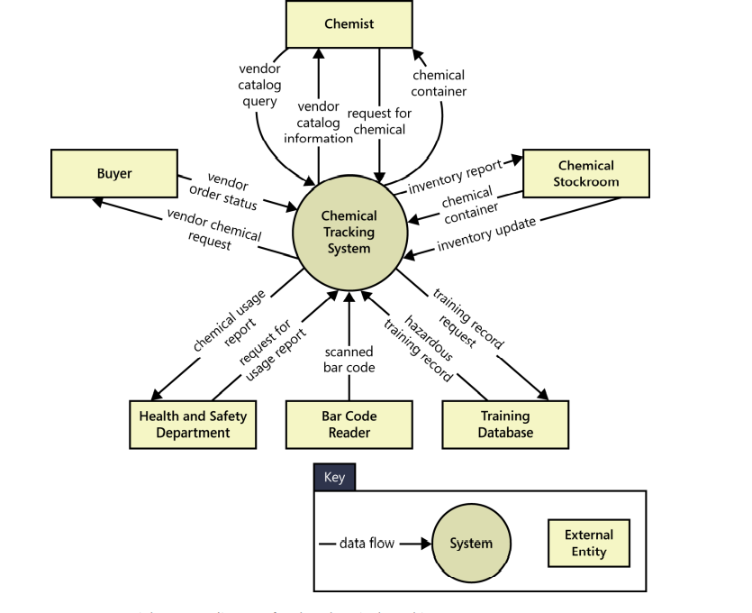

نقشه اکوسیستم

An ecosystem map shows all of the systems related to the system of interest that interact with one another and the nature of those interactions (Beatty and Chen 2012). An ecosystem map represents scope by showing all the systems that interconnect and that therefore might need to be modifed to accommodate your new system. Ecosystem maps differ from context diagrams in that they show other systems that have a relationship with the system you’re working on, including those without direct interfaces. You can identify the affected systems by determining which ones consume data from your system. When you reach the point that your project does not affect any additional data, you’ve identifed the scope boundary of systems that participate in the solution.

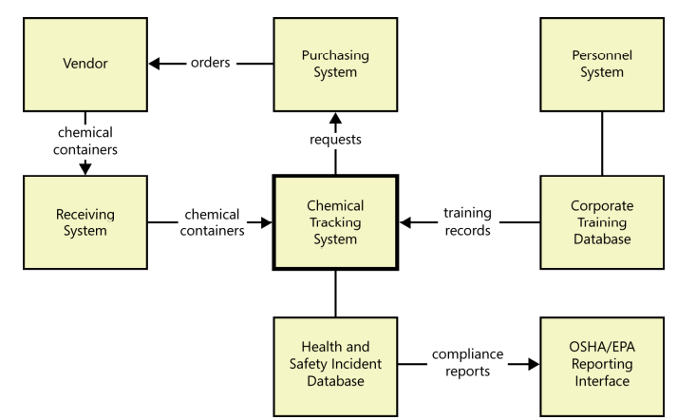

درخت ویژگی ها

A feature tree is a visual depiction of the product’s features organized in logical groups, hierarchically subdividing each feature into further levels of detail (Beatty and Chen 2012). The feature tree provides a concise view of all of the features planned for a project, making it an ideal model to show to executives who want a quick glance at the project scope. A feature tree can show up to three levels of features, commonly called level 1 (L1), level 2 (L2), and level 3 (L3). L2 features are subfeatures of L1 features, and L3 features are subfeatures of L2 features

